Roll Number:2025(S)-CS-83

Lab Tittle: Implementation of Singly Linked List and Basic Operations in C

Lab Objectives
- To understand the concept of dynamic data structures.
- To implement Singly Linked List operations.
- To perform insertion, deletion, and updating of nodes.
- To analyze time complexity of linked list operations.
- To optimize the list using tail pointer and node count

3. Algorithms

Algorithm: Add Node at Start

Create new node and add values in it

In it’s next value pass the header->next

Point header to it

Algorithm: Add Node at End

Create New node add Value in it make it reference Null

Traverse to the Last node of list and then

Pass the address of this newly created Nod in it

Algorithm: Delete from Beginning
- Check if list is empty.
- Store head in temporary pointer.
- Move head to next node.
- Free the temporary node

Algorithm: Add Node at Specific Position
- Create a new node.
- Traverse the list until position-1.
- Set newNode->next = temp->next.
- Set temp->next = newNode.

4. Algorithm: Update Last Node
- Start
- Check if head == NULL
- If true, print "List is empty" and stop
- Create a pointer temp = head
- Traverse the list until temp->next == NULL
- Replace temp->data with the new value
- Stop

5. Algorithm: Update First Node
- Start
- Check if head == NULL
- If true, print "List is empty" and stop
- Replace head->data with the new value
- Stop

8. Algorithm: Delete Last Node
- Start
- Check if head == NULL
- If true, print "List is empty" and stop
- If only one node exists
- Delete head
- Set head = NULL
- Otherwise set temp = head
- Traverse until temp->next->next == NULL
- Delete temp->next
- Set temp->next = NULL
- Stop

Algorithm: Delete Node at Specific Position
- Start
- Input position
- Check if head == NULL
- If true, print "List is empty" and stop
- Set temp = head
- Traverse until reaching position − 1
- Store node to delete nodeToDelete = temp->next
- Link previous node to next node temp->next = nodeToDelete->next
- Delete nodeToDelete
- Stop

Code:

#include<stdio.h>
#include<stdlib.h>

struct node
{
int data;
struct node* next;
};

struct node* head = NULL;
struct node* tail = NULL;
void insert(int value)
{
struct node* newNode = (struct node*)malloc(sizeof(struct node));
newNode->data = value;
newNode->next = NULL;

if (head == NULL)
{
head = newNode;
tail = newNode;
}
else
{
tail->next = newNode;
tail = newNode;
}
}
void AddAtBeginning(int value)
{
struct node* newNode = (struct node*)malloc(sizeof(struct node));
newNode->data = value;
newNode->next = head;
head = newNode;
printf("Added %d at the beginning of the list\n", value);
}
void AddAtEnd(int value)
{
insert(value);
printf("Added %d at the end of the list\n", value);
}
void AddAtPosition(int value, int position)
{
if (position == 1)
{
AddAtBeginning(value);
return;
}
struct node* newNode = (struct node*)malloc(sizeof(struct node));
newNode->data = value;
newNode->next = NULL;
struct node* temp = head;
for (int i = 1; i < position - 1; i++)
{
temp = temp->next;
}
newNode->next = temp->next;
temp->next = newNode;
printf("Added %d at position %d\n", value, position);

}
//Update functions
void UpdateLastNode(int value)
{
if (tail != NULL)
{
tail->data = value;
printf("Updated last node with value %d\n", value);
}
}
void UpdateFirstNode(int value){
if (head != NULL)
{
head->data = value;
printf("Updated first node with value %d\n", value);
}
}
void UpdateAtSpecificPosition(int value, int position)
{
struct node* temp = head;
for (int i = 1; i < position; i++)
{
temp = temp->next;
}
temp->data = value;
printf("Updated position %d with value %d\n", position, value);
}
//Delete functions
void DeleteFirstNode()
{
if (head==NULL)
{
printf("List is empty, cannot delete\n");
return;
}
struct node* temp = head;
head = head->next;
free(temp);
printf("Deleted first node\n");

}
void DeleteLastNode()
{
if (head == NULL)
{
printf("List is empty, cannot delete\n");
return;
}
if (head->next == NULL)
{
free(head);
head = NULL;
tail = NULL;
printf("Deleted last node\n");
return;
}
struct node* temp = head;
while (temp->next != tail)
{
temp = temp->next;
}
free(tail);
tail = temp;
tail->next = NULL;
printf("Deleted last node\n");
}
void DeleteAtSpecificPosition(int position)
{

if (head == NULL)
{
printf("List is empty, cannot delete\n");
return;
}
if (position == 1)
{
DeleteFirstNode();
return;
}
struct node* temp = head;
for (int i = 1; i < position - 1; i++)
{
temp = temp->next;
}
struct node* nodeToDelete = temp->next;
temp->next = nodeToDelete->next;
if (nodeToDelete == tail)
{
tail = temp;
}
free(nodeToDelete);
printf("Deleted node at position %d\n", position);
}
int main()
{
insert(10);
insert(20);
insert(30);
AddAtBeginning(5);
AddAtEnd(40);
AddAtPosition(25, 3);
UpdateLastNode(50);
UpdateFirstNode(15);
UpdateAtSpecificPosition(35, 2);
DeleteFirstNode();
DeleteLastNode();
DeleteAtSpecificPosition(2);
return 0;
}

Output:
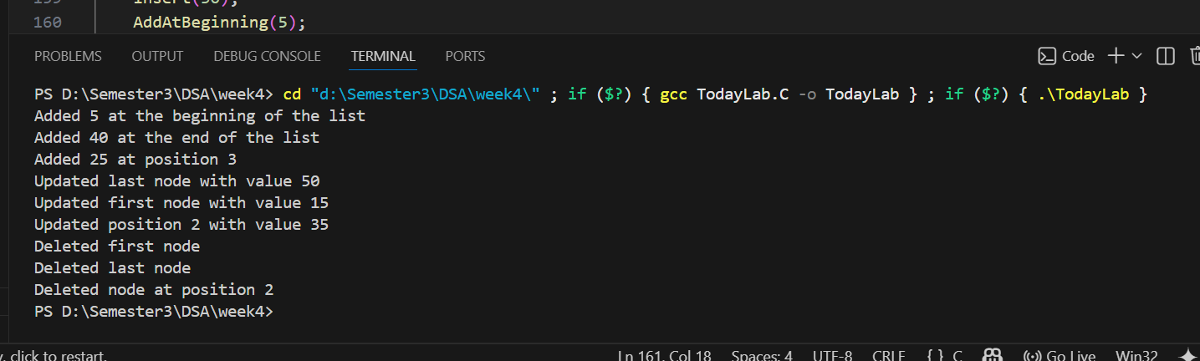

Dry Run:

Initial State
Before main() runs:
head = NULL
tail = NULL
List:
Empty

1️⃣ insert(10)
A new node is created.
newNode -> [10 | NULL]
Since head == NULL:
head = newNode
tail = newNode
List:
10 -> NULL

2️⃣ insert(20)
New node created:
newNode -> [20 | NULL]
Since list already exists:
tail->next = newNode
tail = newNode
List:
10 -> 20 -> NULL

3️⃣ insert(30)
New node created:
newNode -> [30 | NULL]
Update links:
20->next = 30
tail = 30
List:
10 -> 20 -> 30 -> NULL

4️⃣ AddAtBeginning(5)
New node:
newNode -> [5]
Link change:
newNode->next = head
head = newNode
List:
5 -> 10 -> 20 -> 30 -> NULL
Output:
Added 5 at the beginning of the list

5️⃣ AddAtEnd(40)
This calls insert(40).
New node:
[40 | NULL]
Update links:
30->next = 40
tail = 40
List:
5 -> 10 -> 20 -> 30 -> 40 -> NULL
Output:
Added 40 at the end of the list

6️⃣ AddAtPosition(25, 3)
Position = 3
Traversal:
temp = head
temp = 5
temp = 10
New node inserted after 10
Before:
5 -> 10 -> 20 -> 30 -> 40
After insertion:
5 -> 10 -> 25 -> 20 -> 30 -> 40 -> NULL
Output:
Added 25 at position 3

7️⃣ UpdateLastNode(50)
tail currently points to 40
Update:
tail->data = 50
List:
5 -> 10 -> 25 -> 20 -> 30 -> 50 -> NULL
Output:
Updated last node with value 50

8️⃣ UpdateFirstNode(15)
head currently points to 5
Update:
head->data = 15
List:
15 -> 10 -> 25 -> 20 -> 30 -> 50 -> NULL
Output:
Updated first node with value 15

9️⃣ UpdateAtSpecificPosition(35, 2)
Traversal:
temp = head
temp = 15
temp = 10
Update node value:
10 → 35
List:
15 -> 35 -> 25 -> 20 -> 30 -> 50 -> NULL
Output:
Updated position 2 with value 35

🔟 DeleteFirstNode()
Before:
15 -> 35 -> 25 -> 20 -> 30 -> 50
Steps:
temp = head
head = head->next
free(temp)
Node 15 deleted.
List:
35 -> 25 -> 20 -> 30 -> 50 -> NULL
Output:
Deleted first node

11 DeleteLastNode()
Traversal until second last node:
temp stops at 30
Delete tail:
free(50)
tail = 30
tail->next = NULL
List:
35 -> 25 -> 20 -> 30 -> NULL
Output:
Deleted last node

12 DeleteAtSpecificPosition(2)
Position = 2
Traversal:
temp = 35
Node to delete:
nodeToDelete = 25
Pointer update:
35->next = 20
Delete node:
free(25)
Final List:
35 -> 20 -> 30 -> NULL
Output:
Deleted node at position 2

Final Linked List
35 -> 20 -> 30 -> NULL

Time Complexity

Without Optimization
Operation | Time Complexity
Add at start | O(1)
Add at end | O(n)
Add at position | O(n)
Update first | O(1)
Update last | O(n)
Update at position | O(n)
Delete first | O(1)
Delete last | O(n)
Delete at position | O(n)

With Optimization mean use of Tail for Pointing last Node

Using a tail pointer, operations such as insertion at end can be improved to O(1)

Doubly LinkList:

.How Doubly Linked List Works
A Doubly Linked List is a data structure where each node contains:
- Data
- Pointer to the next node
- Pointer to the previous node
Structure of a node:
Prev | Data | Next
Example:
NULL ← 10 ⇄ 20 ⇄ 30 ⇄ 40 → NULL
Explanation:
- Each node can move forward and backward.
- The first node's prev = NULL.
- The last node's next = NULL.
Advantages:
- Easy traversal in both directions
- Easier deletion operations

Algorithms for Doubly Linked List Operations

2. Add Node at End

Algorithm
- Start
- Create a new node
- Store value in node
- Set newNode->next = NULL
- If list is empty
  - head = tail = newNode
- Otherwise
  - tail->next = newNode
  - newNode->prev = tail
  - tail = newNode
- Stop
Time Complexity:
O(1)
(using tail pointer)

3. Add Node at Specific Position

Algorithm
- Start
- Create new node
- Traverse list until position-1
- Set
newNode->next = temp->next
newNode->prev = temp
- Update next node temp->next->prev = newNode
- Set temp->next = newNode
- Stop
Time Complexity: O(n)

4. Add Node at Start

Algorithm
- Start
- Create new node
- newNode->prev = NULL
- newNode->next = head
- If list not empty head->prev = newNode
- Update head = newNode
- Stop
Time Complexity: O(1)

5. Update Last Node

Algorithm
- Start
- Check if list empty
- If not empty tail->data = newValue
- Stop
Time Complexity: O(1)

6. Update First Node

Algorithm
- Start
- Check if list empty
- If not empty head->data = newValue
- Stop
Time Complexity: O(1)

7. Update Node at Specific Position

Algorithm
- Start
- Input position
- Traverse list until that position
- Replace node data with new value temp->data = newValue
- Stop
Time Complexity:O(n)

8. Delete First Node

Algorithm
- Start
- If list empty → stop
- Store head in temptemp = head
- Move head forward head = head->next
- If head not NULL head->prev = NULL
- Delete temp
- Stop
Time Complexity:O(1)

9. Delete Last Node

Algorithm
- Start
- If list empty → stop
- Store tail in temp temp = tail
- Move tail backward tail = tail->prev
- Set tail->next = NULL
- Delete temp
- Stop
Time Complexity:O(1)
(using tail pointer)

10. Delete Node at Specific Position

Algorithm
- Start
- Traverse list until position
- Store node to delete
nodeToDelete = temp
- Update pointers
temp->prev->next = temp->next
temp->next->prev = temp->prev
- Delete node
- Stop
Time Complexity:O(n)

11. Optimization using Head + Tail
Using two pointers:
head → first node
tail → last node
Benefits:
Operation | Without Tail | With Tail
Insert at End | O(n) | O(1)
Delete Last | O(n) | O(1)
Update Last | O(n) | O(1)
So head + tail optimization significantly improves performance

Code:
#include <stdio.h>
#include <stdlib.h>

typedef struct DNode {
int data;
struct DNode* prev;
struct DNode* next;
} DNode;

DNode* head = NULL;

// Display forward
void displayForward() {
if (head == NULL) {
printf("List is empty.\n");
return;
}
DNode* temp = head;
while (temp != NULL) {
printf("%d <-> ", temp->data);
temp = temp->next;
}
printf("NULL\n");
}

// 1. Add node at start
void addAtStart(int value) {
DNode* newNode = (DNode*)malloc(sizeof(DNode));
newNode->data = value;
newNode->prev = NULL;
newNode->next = head;
if (head != NULL)
head->prev = newNode;
head = newNode;
}

// 2. Add node at end
void addAtEnd(int value) {
DNode* newNode = (DNode*)malloc(sizeof(DNode));
newNode->data = value;
newNode->next = NULL;
newNode->prev = NULL;

if (head == NULL) {
head = newNode;
return;
}

DNode* temp = head;
while (temp->next != NULL)
temp = temp->next;

temp->next = newNode;
newNode->prev = temp;
}

// 3. Add node at specific position
void addAtPosition(int value, int position) {
if (position < 1) {
printf("Invalid position.\n");
return;
}
if (position == 1) {
addAtStart(value);
return;
}

DNode* temp = head;
for (int i = 1; i < position - 1 && temp != NULL; i++)
temp = temp->next;

if (temp == NULL) {
printf("Position out of range.\n");
return;
}

DNode* newNode = (DNode*)malloc(sizeof(DNode));
newNode->data = value;
newNode->next = temp->next;
newNode->prev = temp;
if (temp->next != NULL)
temp->next->prev = newNode;
temp->next = newNode;
}

// 4. Update first node
void updateFirstNode(int value) {
if (head == NULL) {
printf("List is empty.\n");
return;
}
head->data = value;
}

// 5. Update last node
void updateLastNode(int value) {
if (head == NULL) {
printf("List is empty.\n");
return;
}

DNode* temp = head;
while (temp->next != NULL)
temp = temp->next;

temp->data = value;
}

// 6. Update node at specific position
void updateAtPosition(int value, int position) {
if (position < 1) {
printf("Invalid position.\n");
return;
}

DNode* temp = head;
for (int i = 1; i < position && temp != NULL; i++)
temp = temp->next;

if (temp == NULL) {
printf("Position out of range.\n");
return;
}
temp->data = value;
}

// 7. Delete first node
void deleteFirstNode() {
if (head == NULL) {
printf("List is empty.\n");
return;
}

DNode* temp = head;
head = head->next;
if (head != NULL)
head->prev = NULL;
free(temp);
}

// 8. Delete last node
void deleteLastNode() {
if (head == NULL) {
printf("List is empty.\n");
return;
}
if (head->next == NULL) {
free(head);
head = NULL;
return;
}

DNode* temp = head;
while (temp->next != NULL)
temp = temp->next;

temp->prev->next = NULL;
free(temp);
}

// 9. Delete node at specific position
void deleteAtPosition(int position) {
if (head == NULL) {
printf("List is empty.\n");
return;
}
if (position < 1) {
printf("Invalid position.\n");
return;
}
if (position == 1) {
deleteFirstNode();
return;
}

DNode* temp = head;
for (int i = 1; i < position && temp != NULL; i++)
temp = temp->next;

if (temp == NULL) {
printf("Position out of range.\n");
return;
}

if (temp->next != NULL)
temp->next->prev = temp->prev;
if (temp->prev != NULL)
temp->prev->next = temp->next;

free(temp);
}

// Main function
int main() {
addAtEnd(10);
addAtEnd(20);
addAtEnd(30);
printf("Initial Doubly Linked List: ");
displayForward();

addAtStart(5);
printf("After adding at start: ");
displayForward();

addAtPosition(15, 3);
printf("After adding 15 at position 3: ");
displayForward();

updateFirstNode(100);
printf("After updating first node: ");
displayForward();

updateLastNode(300);
printf("After updating last node: ");
displayForward();

updateAtPosition(200, 3);
printf("After updating node at position 3: ");
displayForward();

deleteFirstNode();
printf("After deleting first node: ");
displayForward();

deleteLastNode();
printf("After deleting last node: ");
displayForward();

deleteAtPosition(2);
printf("After deleting node at position 2: ");
displayForward();

return 0;
}

Output:

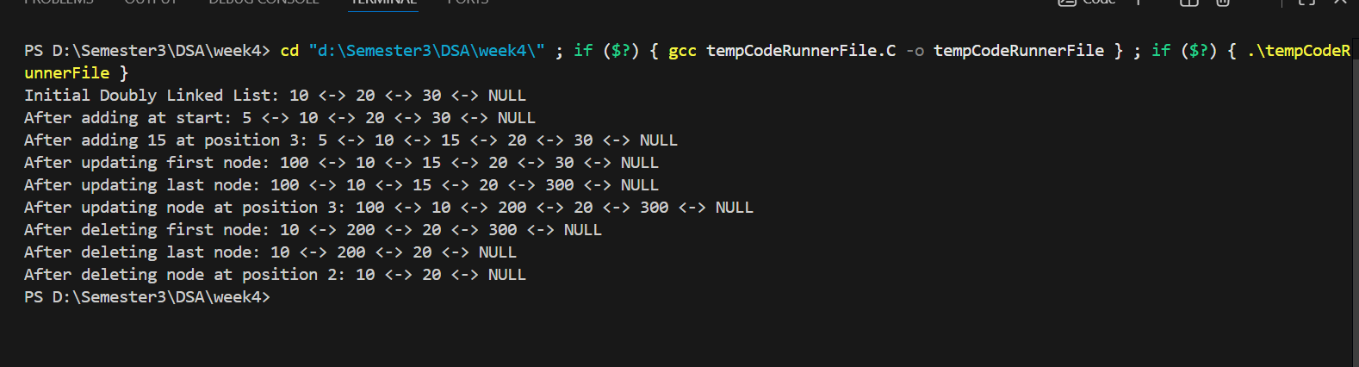
6. Time Complexity Table for Doubly Linked List
Operation  Add at start  Add at end  Add at position  Update first | O(1)  O(n)  O(n)  O(1)
Operation Time Complexity

Update last O(n)

Update at position O(n)

Delete first O(1)

Delete last O(n)

Delete at position O(n)
7. Optimization for Doubly Linked List
Use Both Head and Tail
If we maintain:
DNode* head; DNode* tail;
Then:
• add at end becomes O(1)
• update last becomes O(1)
• delete last becomes O(1)

This is one of the major advantages of doubly linked list over singly linked list

Conclusion:
A doubly linked list improves traversal and deletion efficiency compared to singly linked lists. Using both head and tail pointers further optimizes operations such as insertion and deletion at the end, reducing their complexity to constant time.

